Mahasiswa Kit | Project Description
Tech Stack:  Kotlin, Jetpack Compose, Material Design 3, Dagger Hilt, Room, DataStore, WorkManager, Jsoup. | MahasiswaKit is a mobile application designed specifically for university students to manage their academic workload, track money expense, track deadlines, implement pomodoro technique, and stay informed with curated local and global news. As the sole architect and developer, I designed and implemented the complete application from UI layer to local data persistence, building a robust offline-first system that enables students to remain productive regardless of connectivity. My contributions spanned across modern Android architecture patterns, declarative UI implementation with Jetpack Compose, sophisticated local data management, and background task processing.  The main challenge was extracting news data from various sources with inconsistent and frequently changing HTML structures. I resolved this by optimizing the parsing logic using JSoup and implementing robust error handling to ensure data accuracy. This experience deepened my understanding of data extraction and building adaptive mobile applications.
2026 | 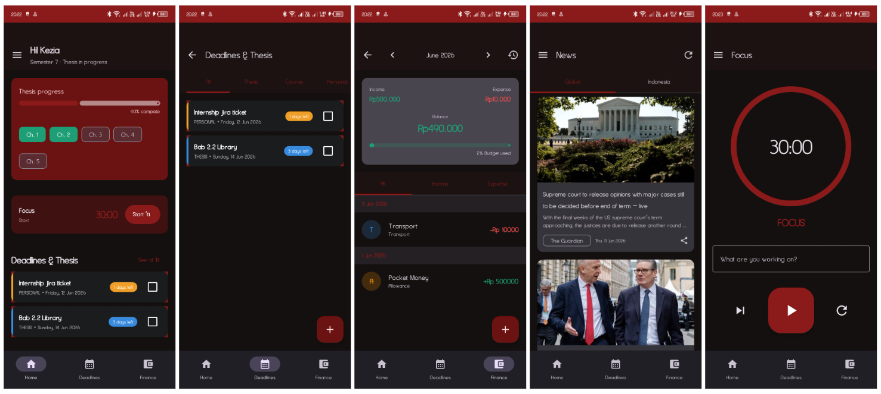
Full Stack
https://github.com/KeziaNatalia22/MahasiswaKit

Valuate CRM | Project Description
Tech Stack:  React + TypeScript, Material-UI, React Router, Jest | Valuate-CRM is an enterprise-grade Employee Management System built by our team of four developer to streamline Human Resources operations. As a contributor, I was responsible for implementing the User Management, User Tree Hierarchy, Reimbursement System, and Attendance modules, including the advanced QR-based attendance verification system. My contributions focused on developing complete end-to-end features spanning from backend API architecture to interactive frontend interfaces, ensuring seamless integration across the web and mobile platforms.  The main challenges I faced was implementing the QR attendance system securely while handling real-time code generation and verification. Unlike traditional static QR codes, we needed dynamic, time-limited codes that couldn't be reused or forged.
2026 | 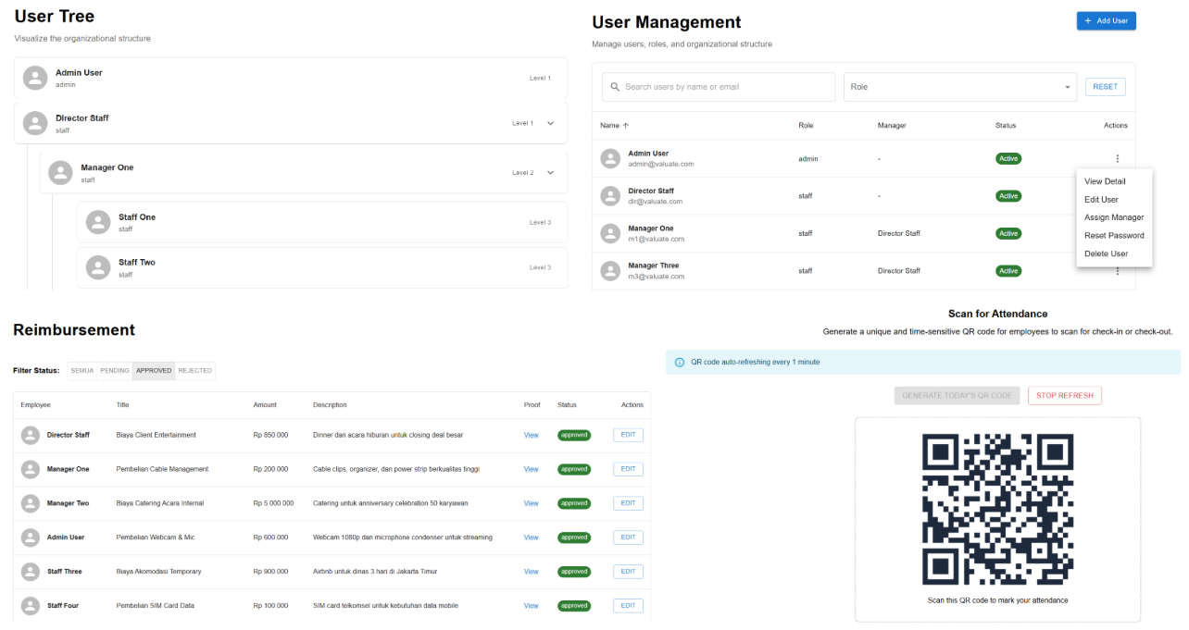
Front end
https://github.com/HoseaStefan/valuate-CRM

Dapur Pedia | Project Description
Tech Stack:  Kotlin, Jetpack Compose, Dagger Hilt, Room, DataStore, Jsoup. | Dapur Pedia is an Android-based developed by a team of three developers, full-stack recipe discovery application developed to streamline the culinary experience, I was responsible for implementing the mobile architecture and core user features. My contributions spanned across RESTful API integration, local data persistence, content categorization, and engagement systems, including an offline-first caching mechanism with Room, reactive state management with Kotlin Coroutines/StateFlow, and a modular dependency injection system using Dagger Hilt.  The main challenges was managing the data synchronization between the remote API and the local database, including asynchronous request handling, state synchronization between the repository and the UI, and ensuring consistent data validation when parsing complex JSON responses.
2026 | 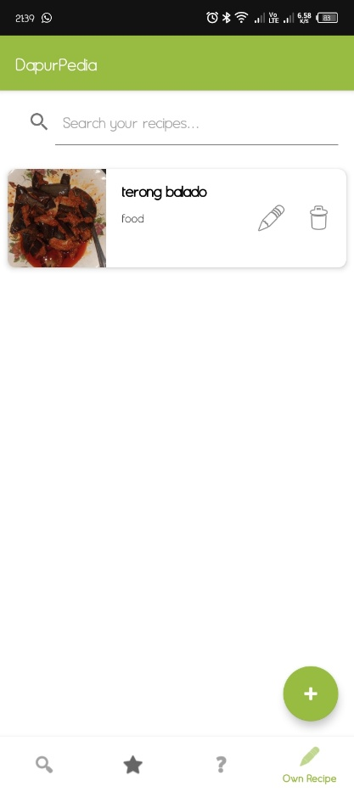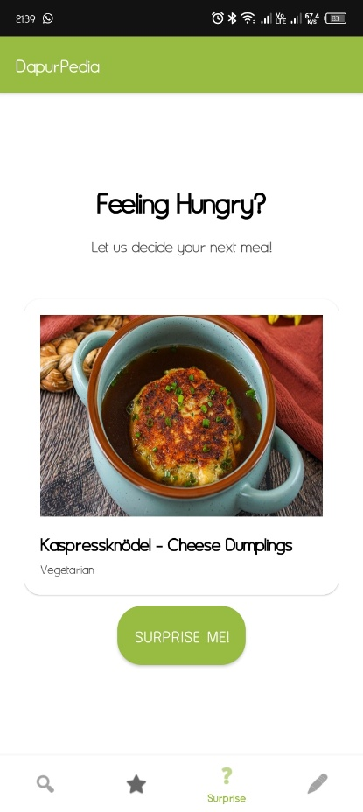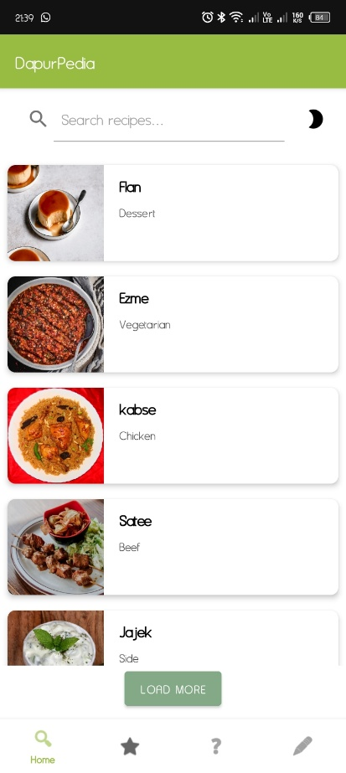
Full Stack
https://github.com/richi-51/Food_Recipe_Finder

Meme Gang | Project Description
Tech Stack: Typescript, Material UI, React, Express | Meme Gang is a 9GAG-inspired, full-stack meme-sharing web application developed by a team of three developers, where I served as a key contributor responsible for implementing critical backend systems and user-facing features. My contributions spanned across profile management, comment systems, and content discovery.  The main challenges was handling redundant API calls and preventing duplicate submissions, which caused severe performance degradation and data inconsistency issues. Users could accidentally submit multiple votes on the same post, create duplicate comments, and trigger unnecessary database queries.
2025 | 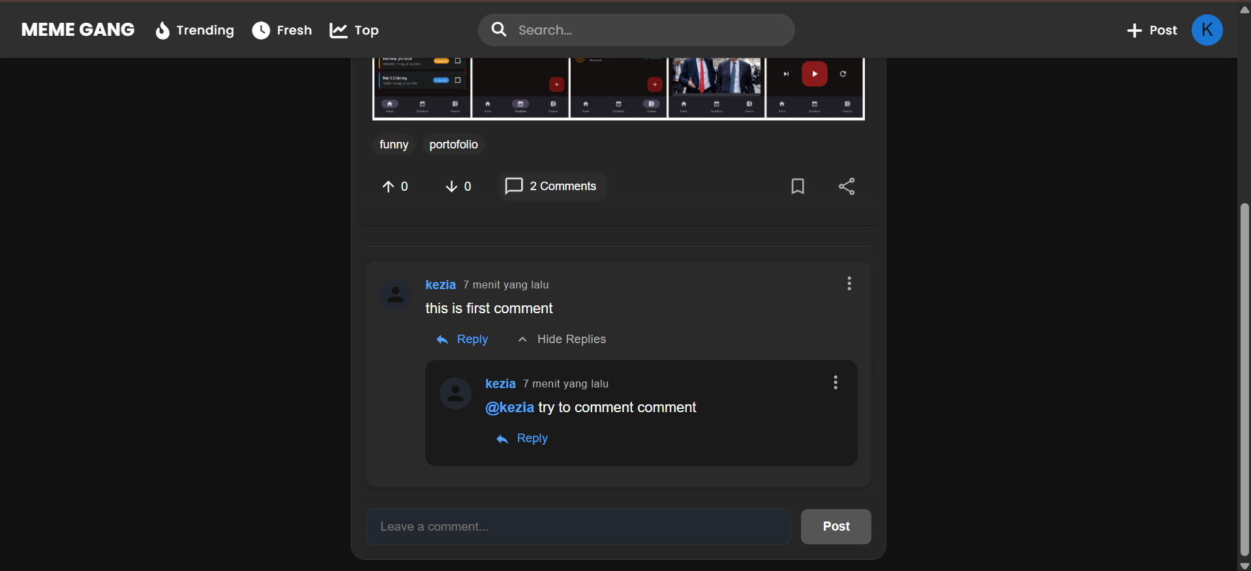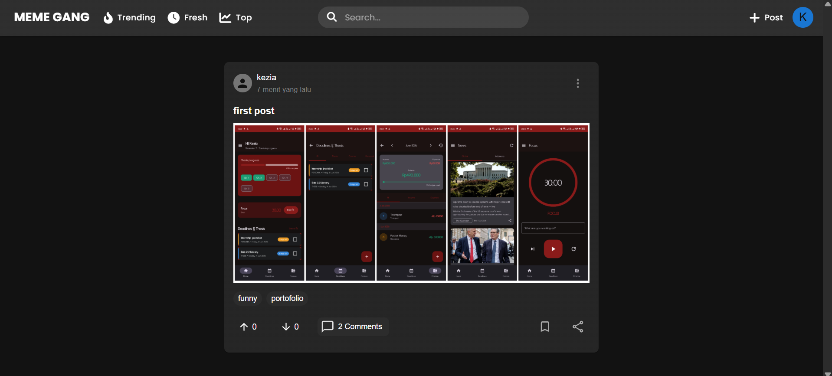  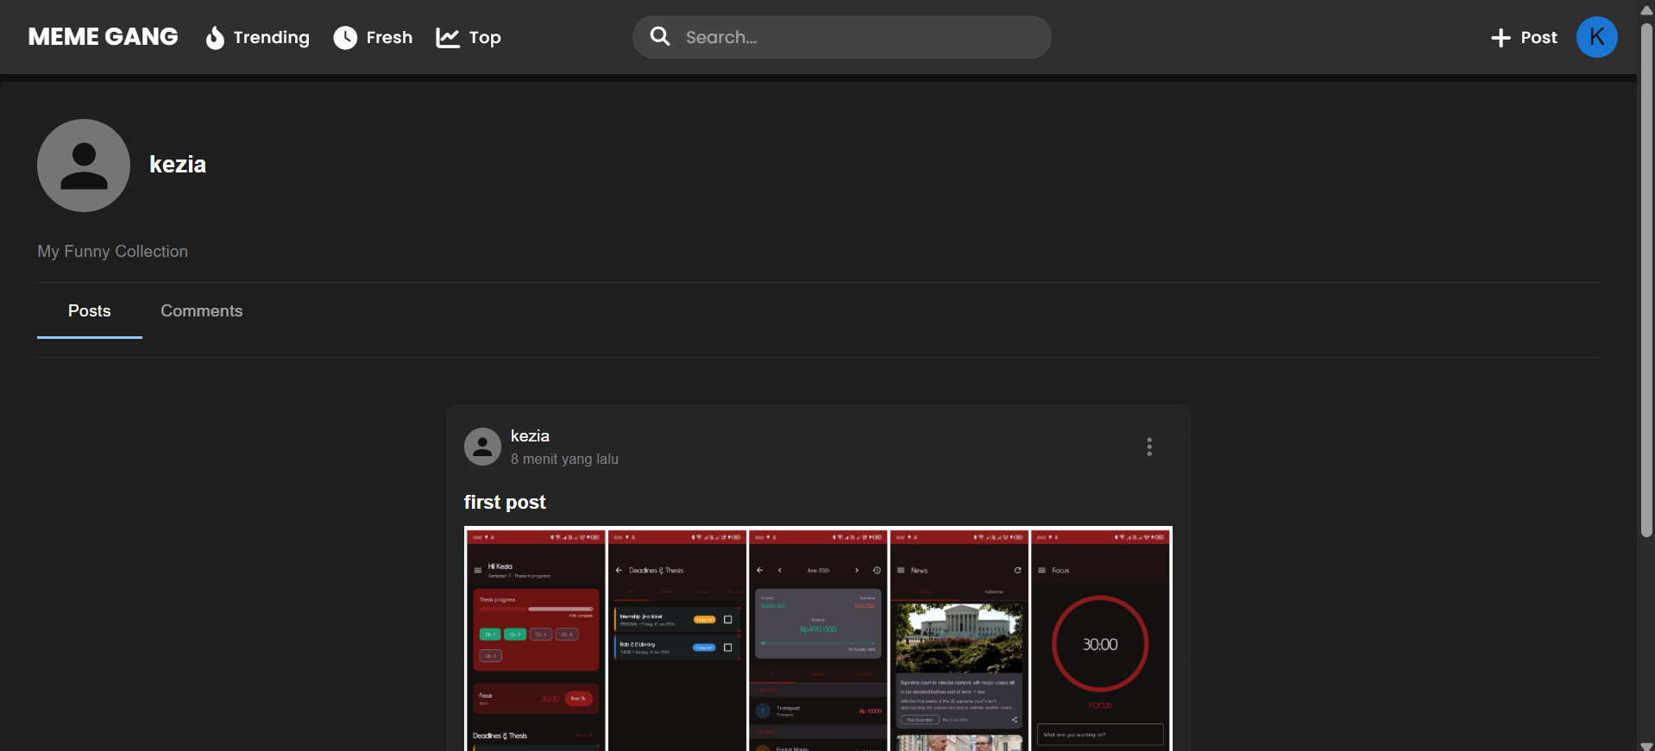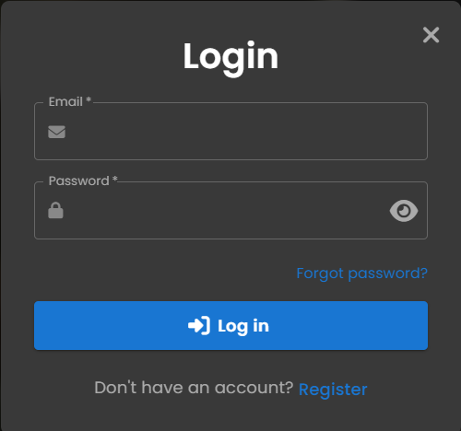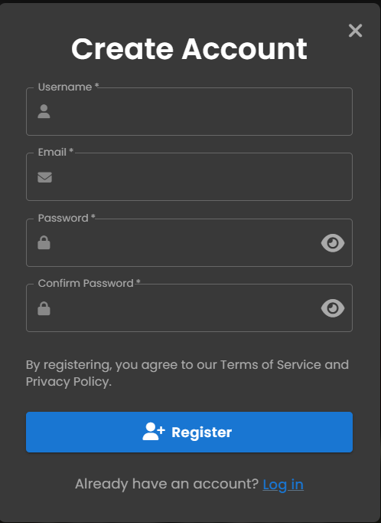
Full Stack
https://github.com/juanSunitsuga/meme-gang

E-Learning | Project Description
Tech Stack: Javascript, HTML, CSS, Express | E-Learning is a full-stack learning management system developed by a team of three developers, where I implemented backend systems and frontend integration across user authentication, course management, learner progress tracking, and payment processing.  The main challenges were managing frontend-backend integration complexity, including asynchronous API request handling, state synchronization between client and server, CORS and token refresh mechanisms, and ensuring consistent validation between client-side and server-side logic. Additional challenges included preventing race conditions during rapid navigation, handling concurrent transactions, and debugging API response format mismatches.
2025 | 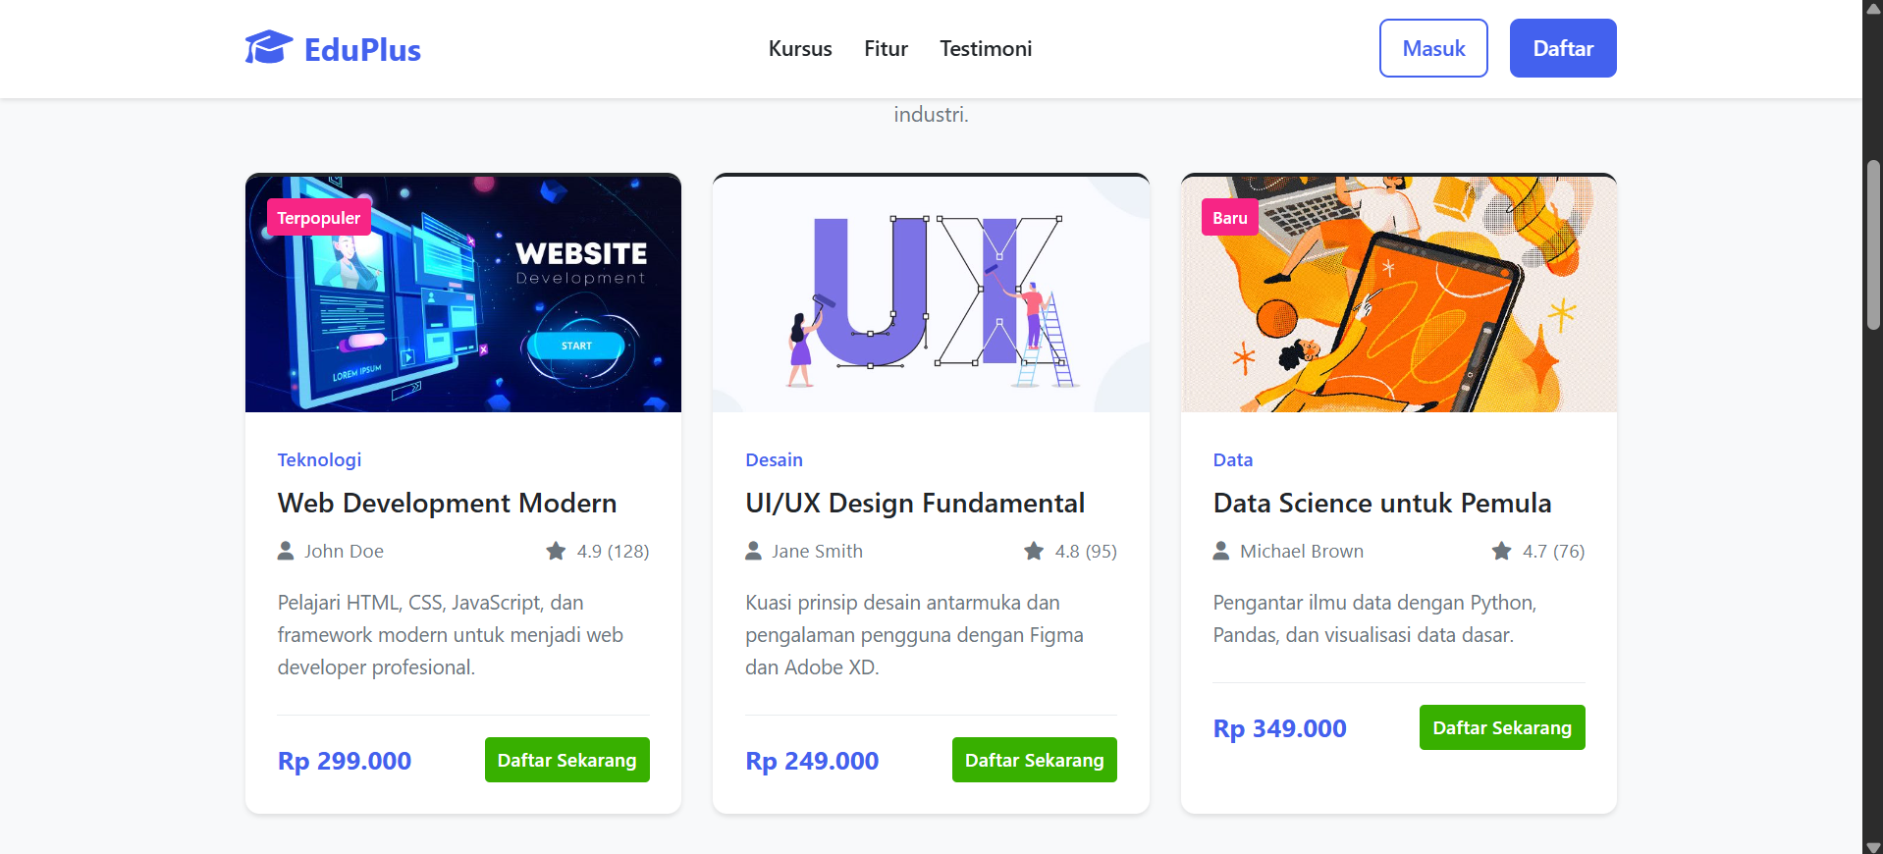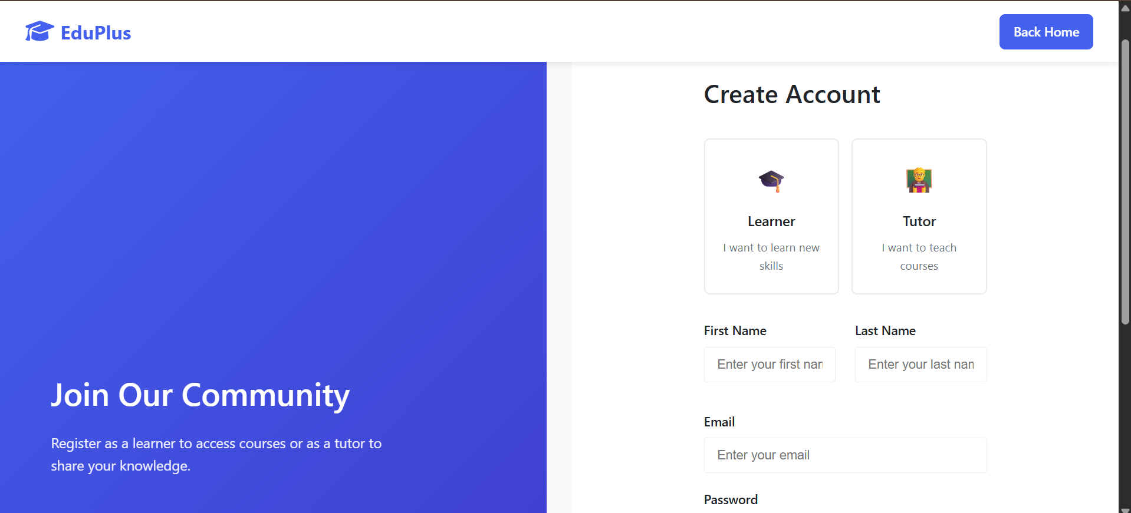  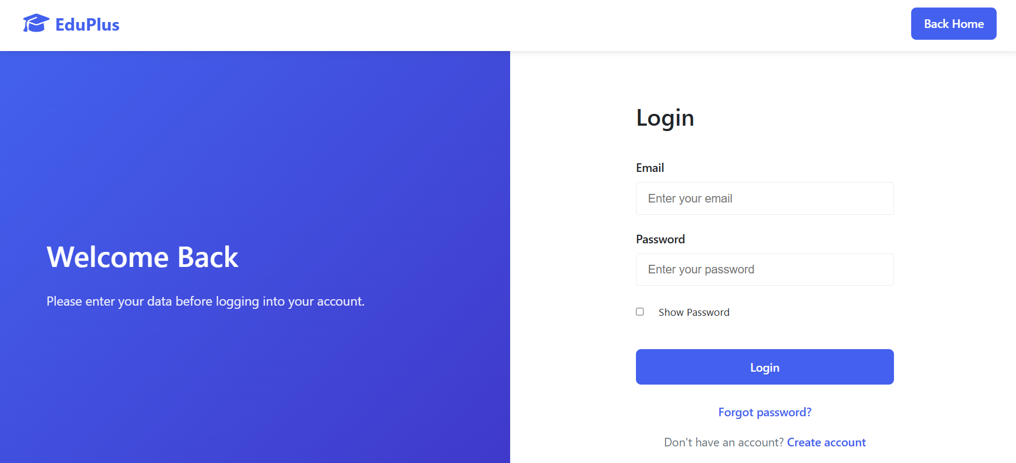
Full Stack
https://github.com/JeshaAlkeba044/E-Learning

TokosiDia | Project Description
Tech Stack:  Java, MySQL, Java Library | TokoSiDia is Java based e-commerce platform where developed by a team of three developers, I implemented critical features including multi-role authentication (buyer/seller), product catalog management, transaction processing, shipment tracking.  The main challenges was managing concurrent operations and preventing data inconsistencies. Issues included duplicate cart items from simultaneous additions, race conditions in inventory updates, inconsistent transaction history, duplicate email notifications, and stale product data during real-time updates.
2025 | 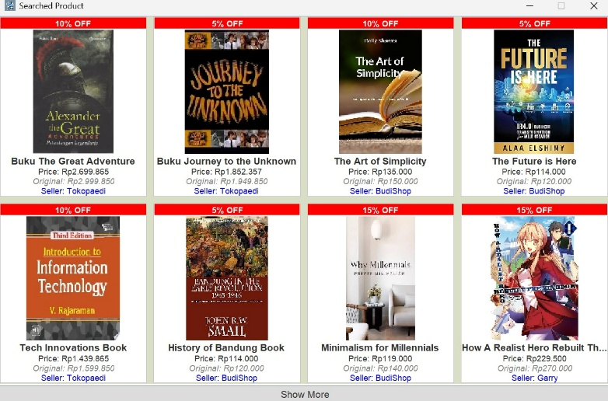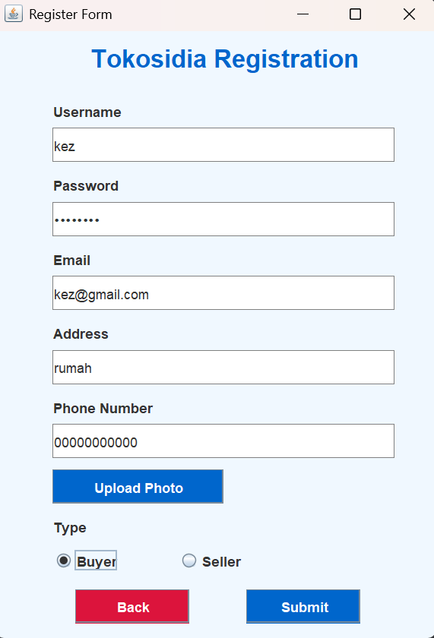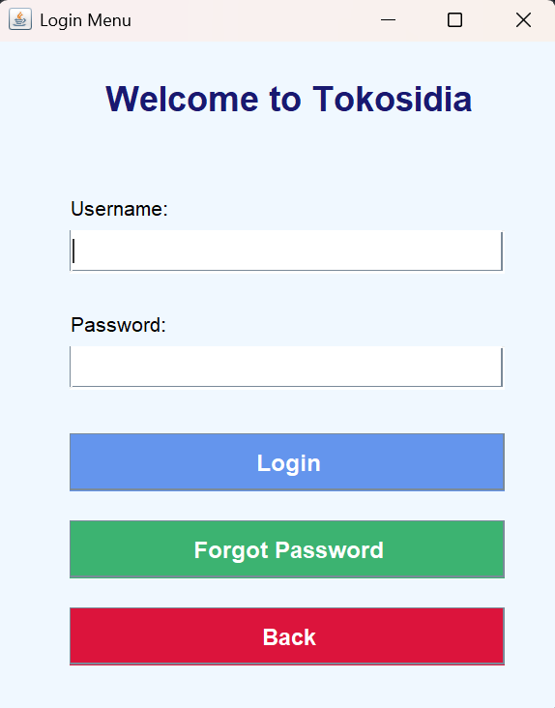  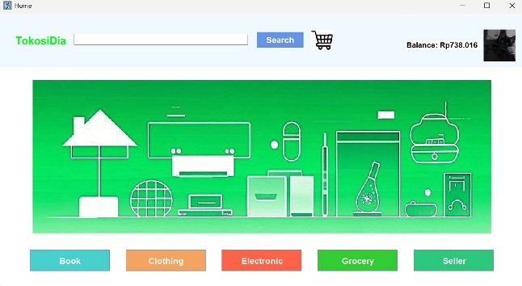
Full Stack
https://github.com/KeziaNatalia22/TokoSiDia

